LAB SHEET - 07

**Name : Ranudi Gayathmie Kariyapperuma**

**Index : 29897**

**Batch No : 23.1**

**Degree Program Name : Technology Management**

Q1.

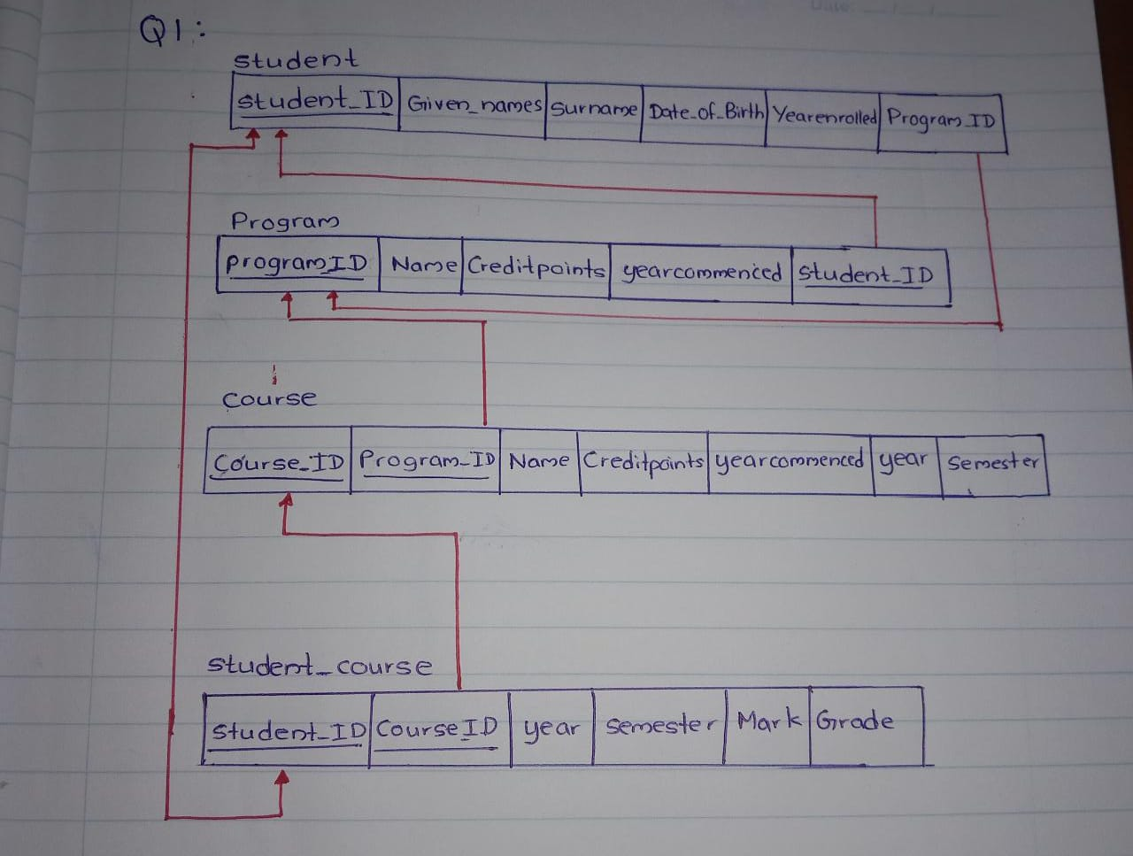

Q2

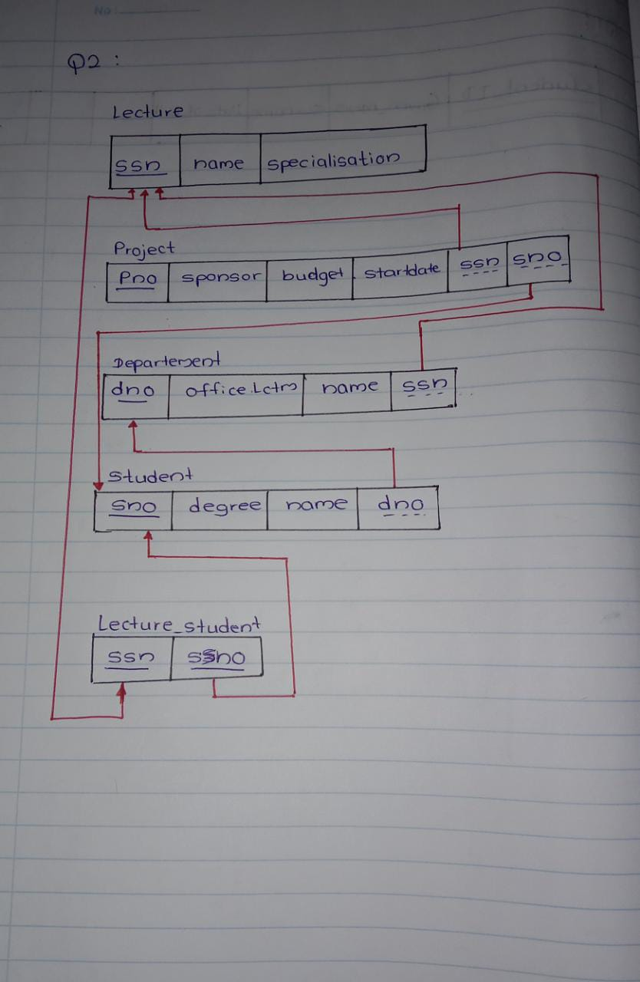

Q3

